Nama : Aliffio Syah M

NIM : 41519120065

Mata Kuliah : Pemrograman Web Enterprise

**Tugas Pertemuan 11**

**NextJS :**

**Buku Upload Cover with delete function**

**Step to Finish :**

**Add column cover in buku table**

**Create action button upload in buku list**

**Create upload button**

**Display image with delete button**

**Answer**

**Add column cover in buku table**

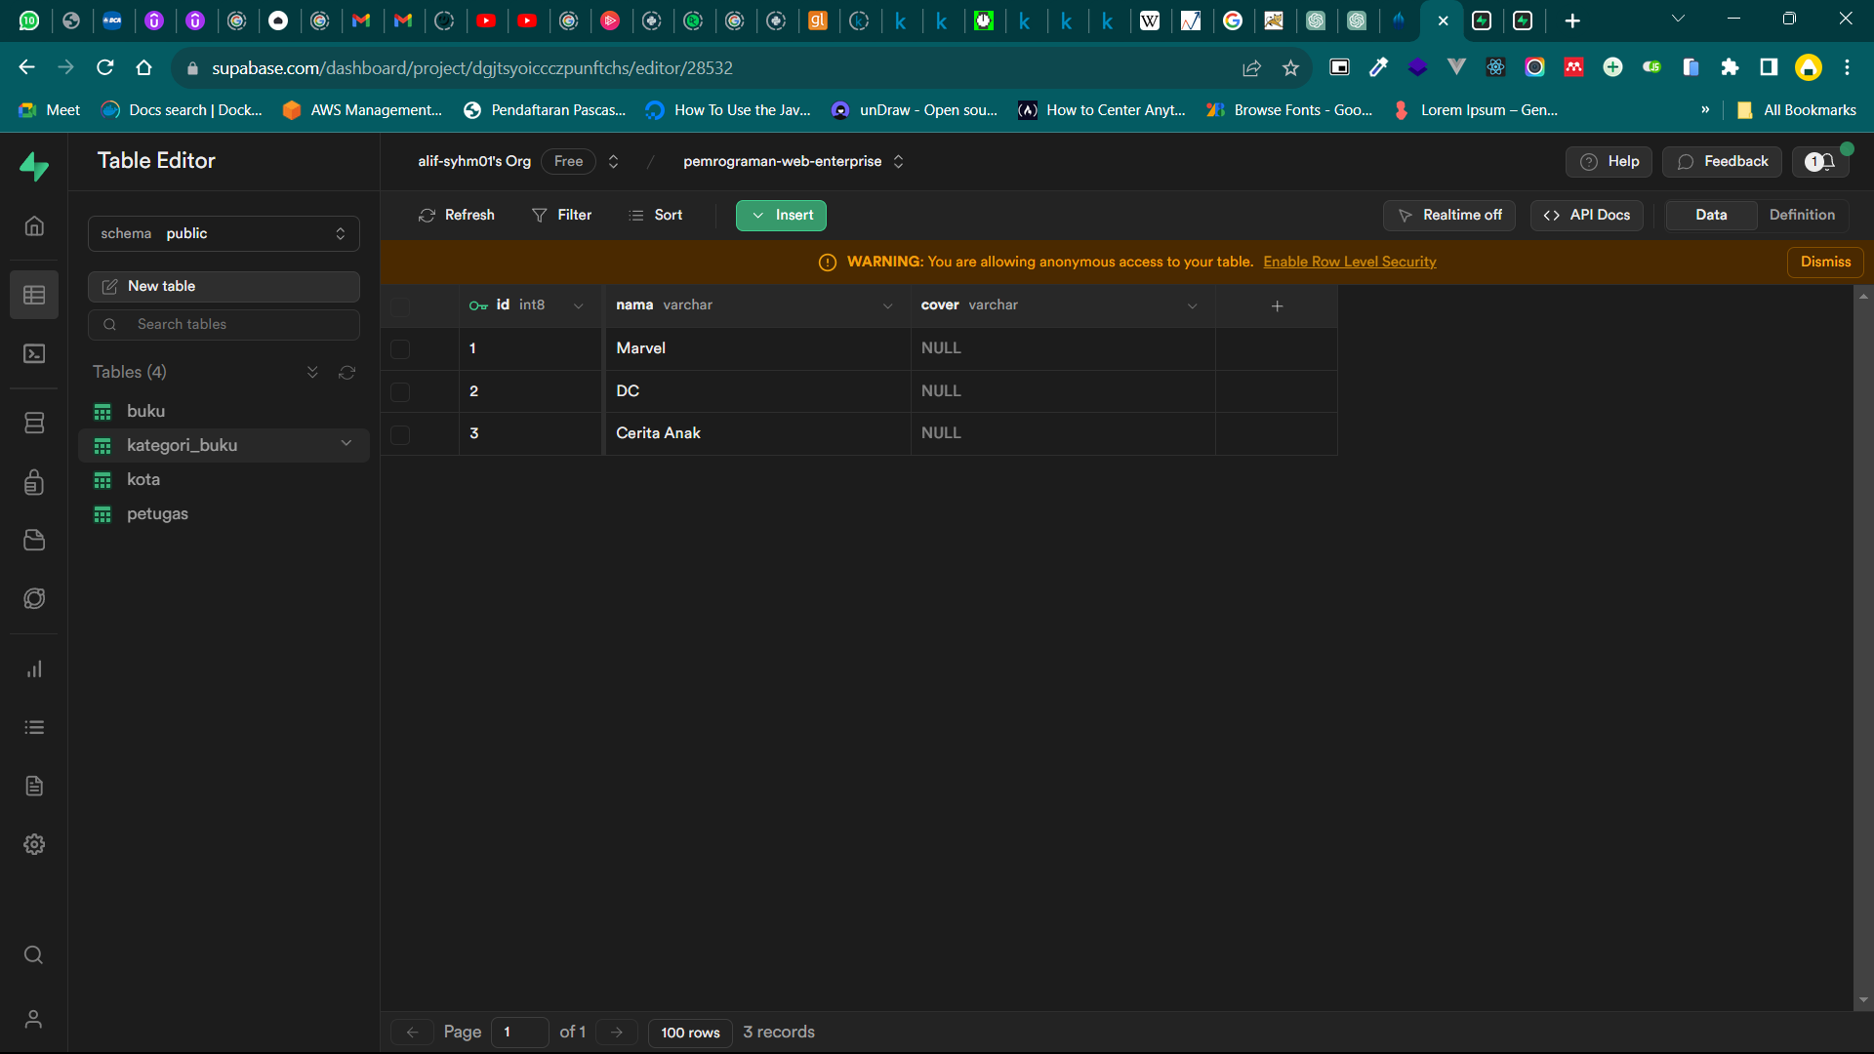

**Create action button upload in buku list**

**Code:**

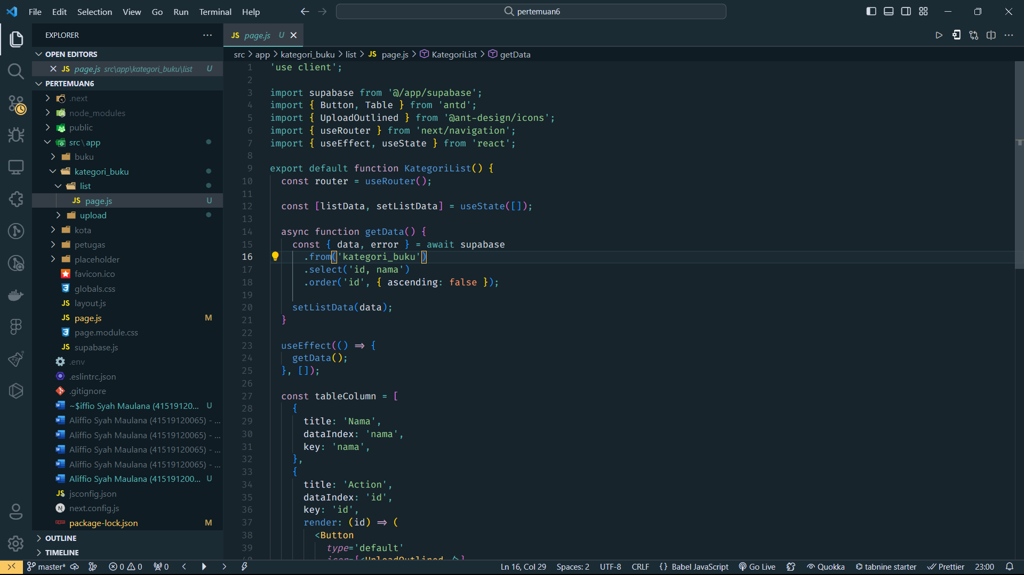

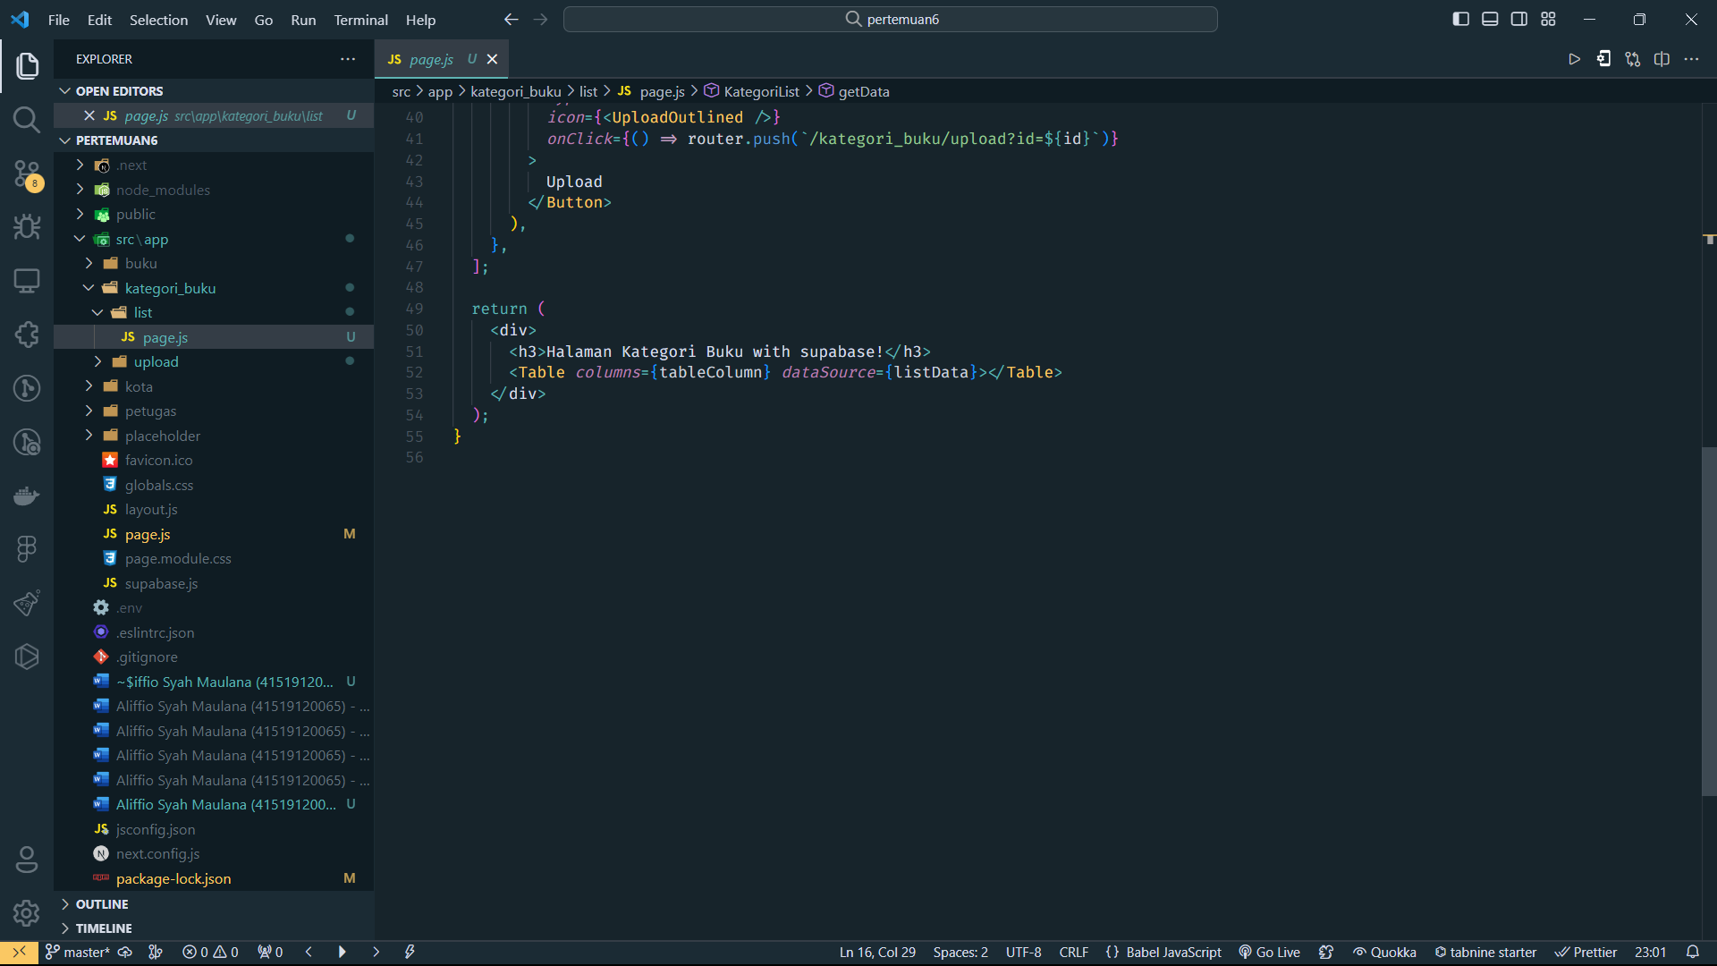

**Result:**

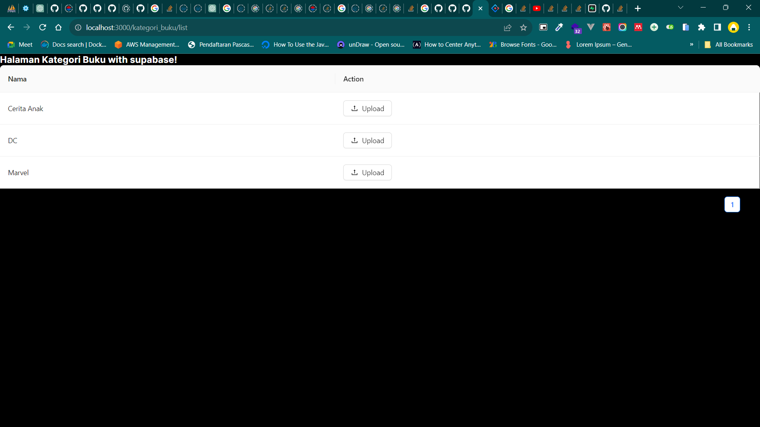

**Create upload button**

**Code:**

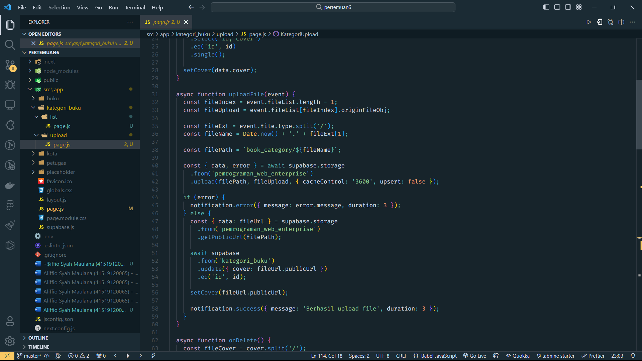

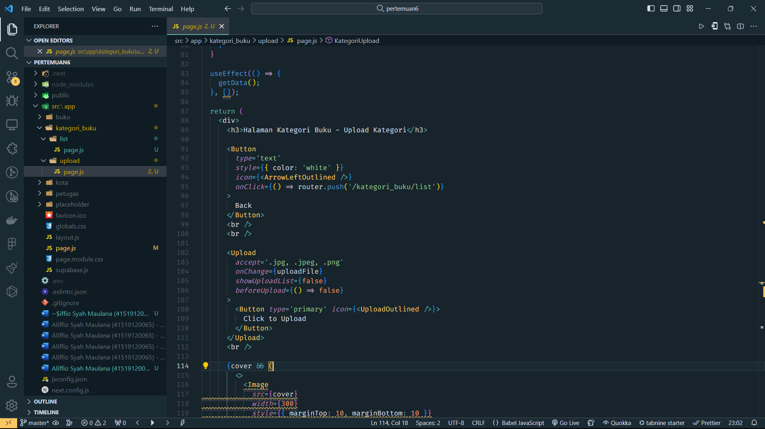

**Result:**

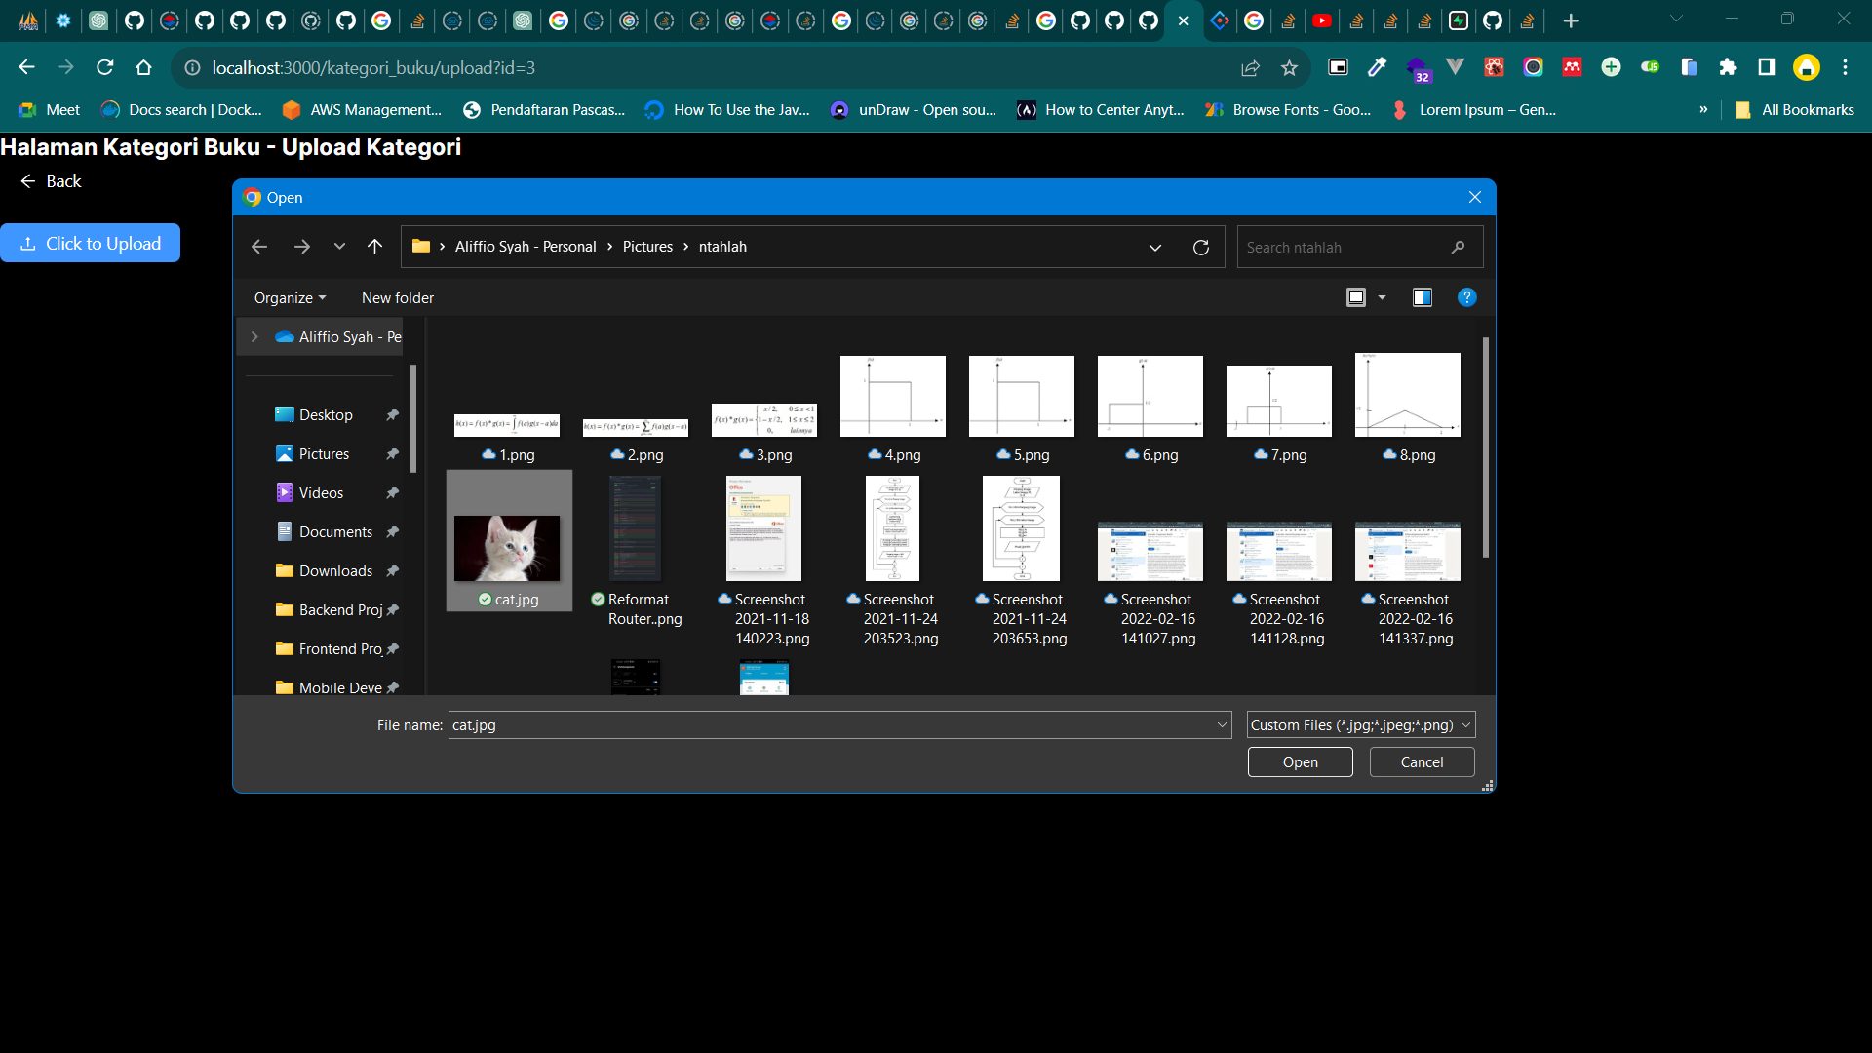

**Display image with delete button**

**Code:**

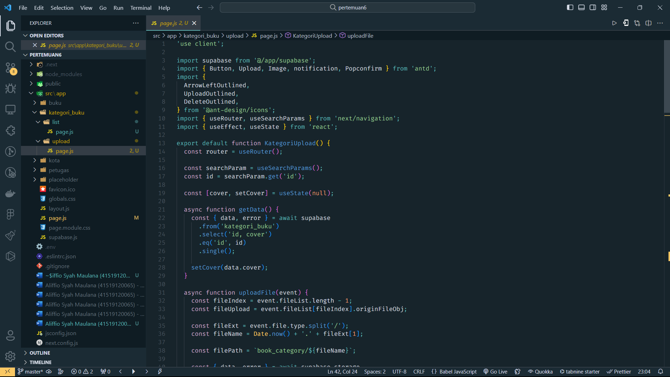

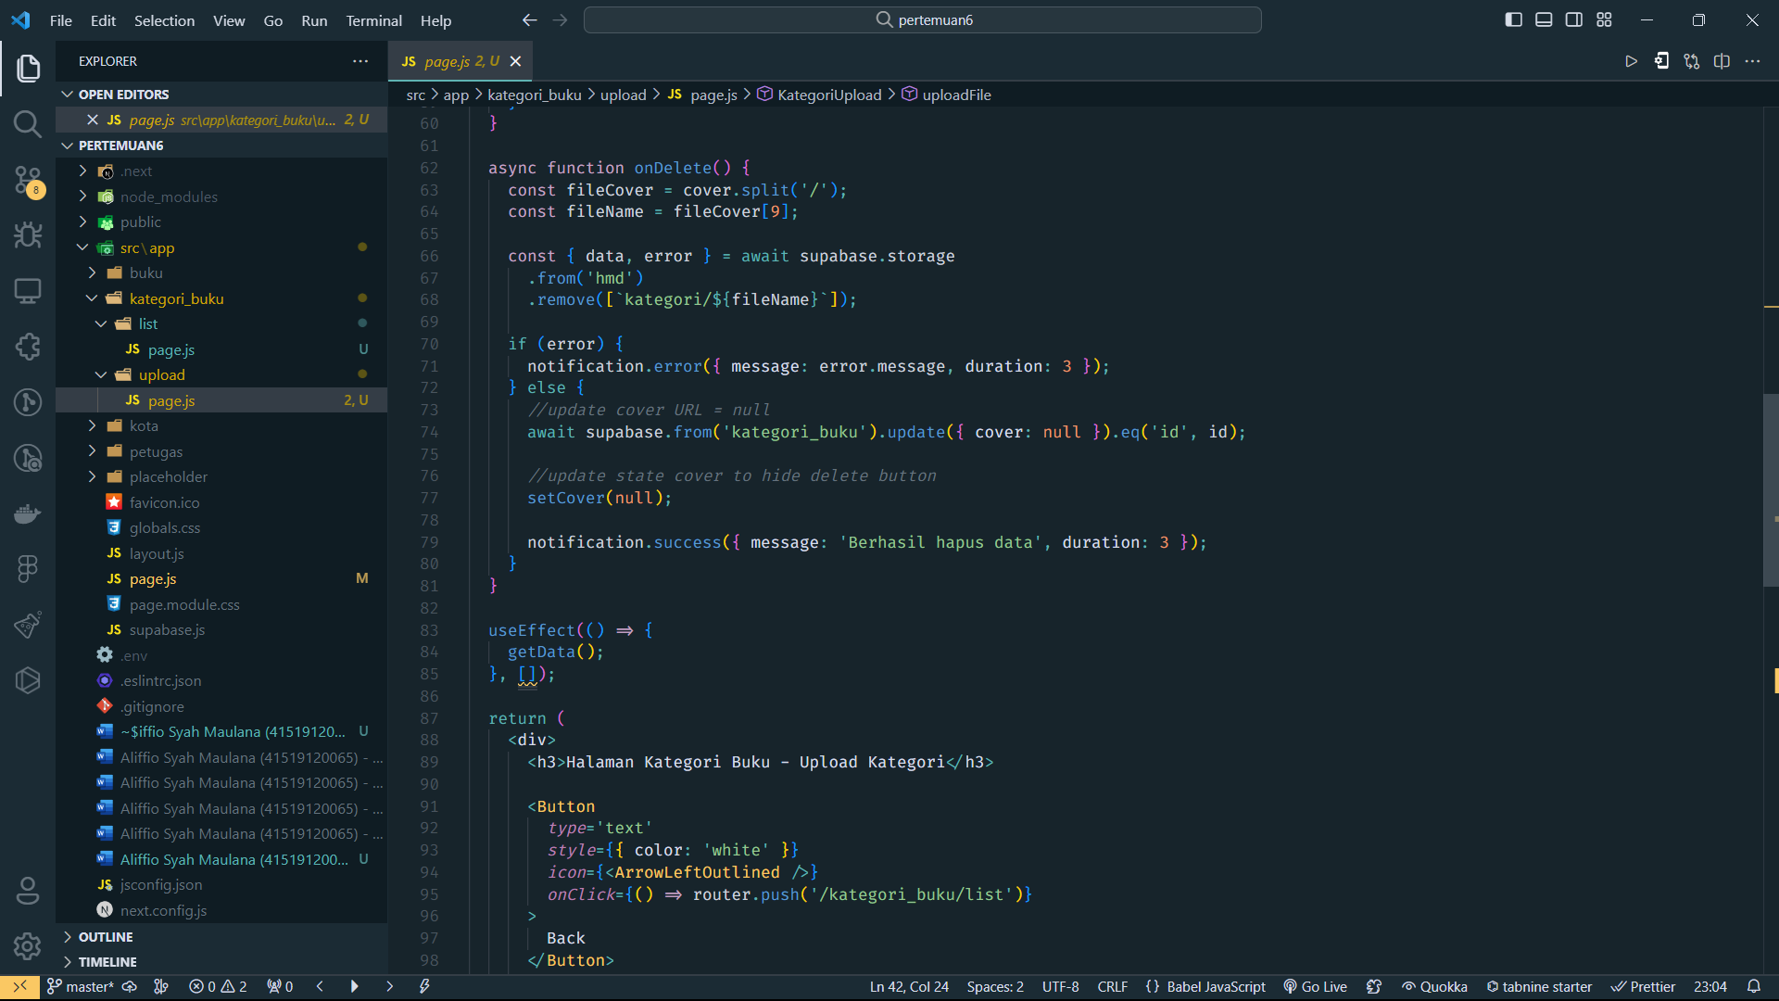

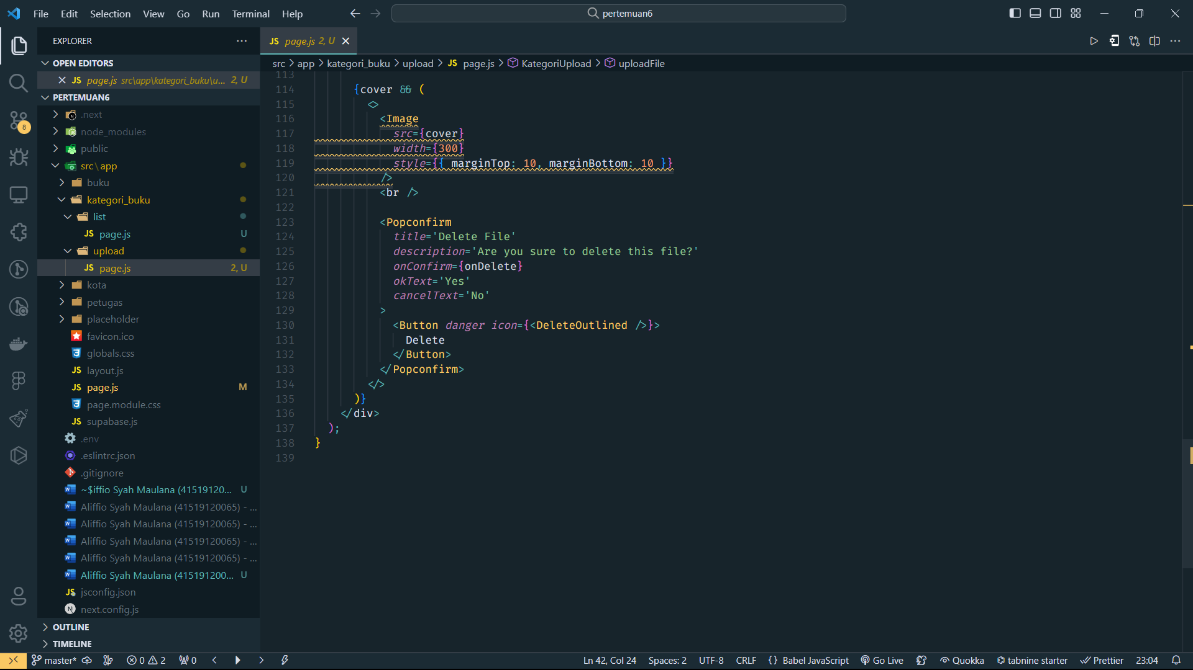

**Result:**

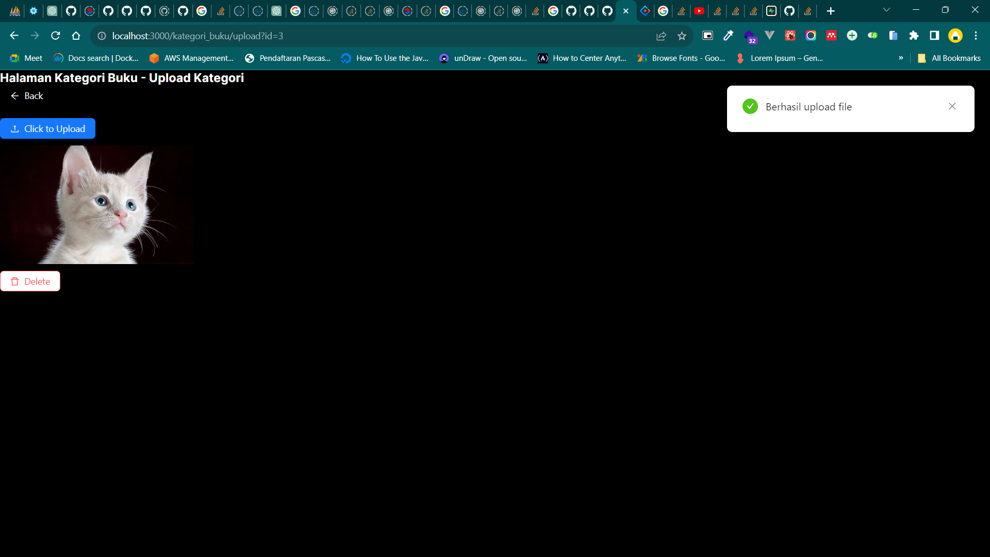

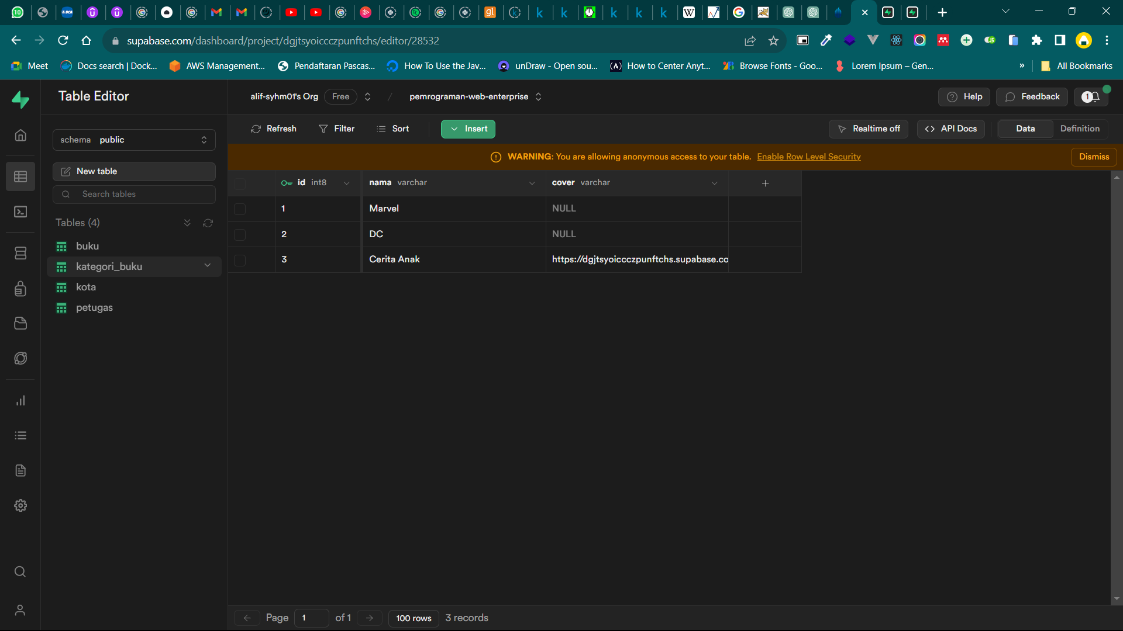

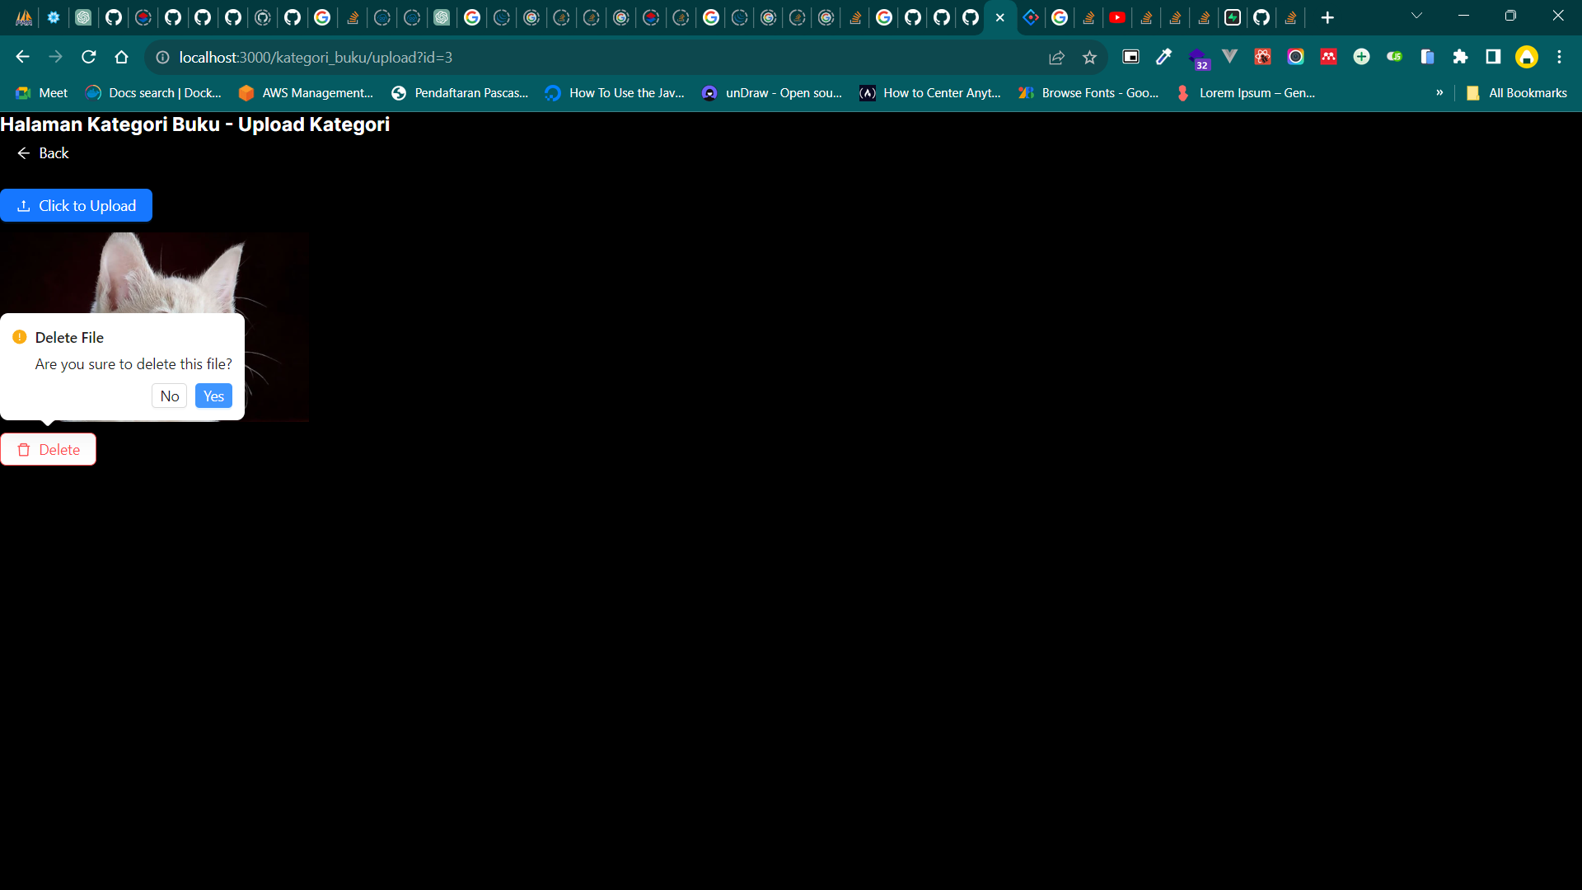

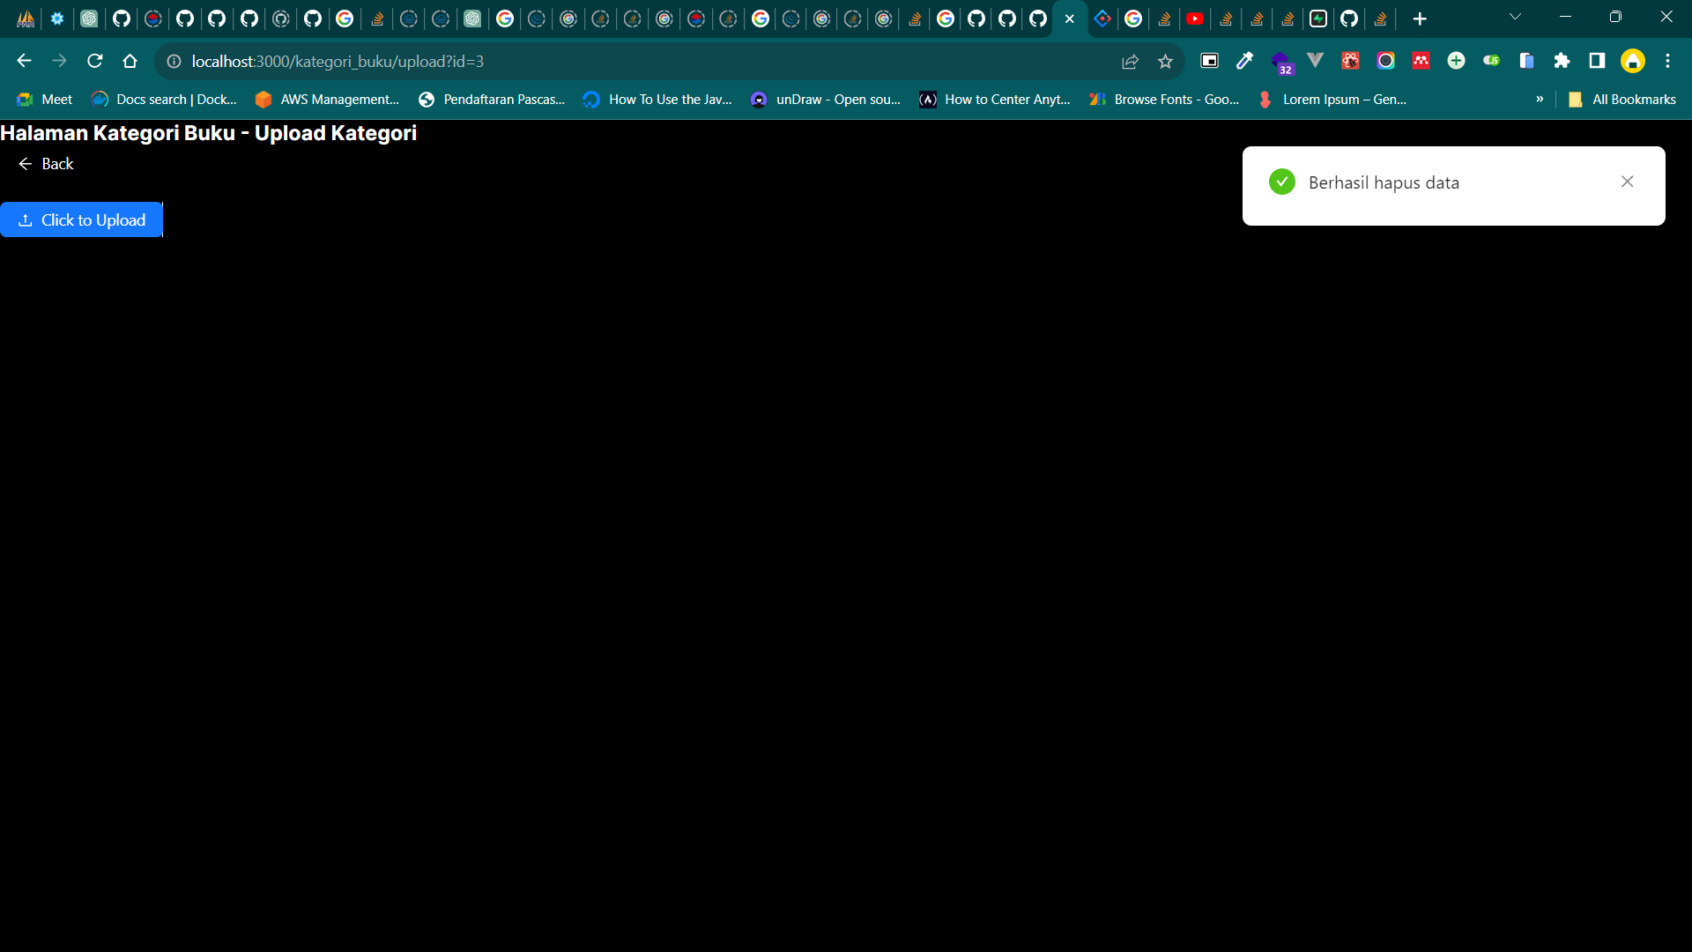



**Complete Code in Github:**

<https://github.com/alif-syhm01/pemrograman-web-enterprise-pertemuan6.git>